Please fill out this form to give the support team as much information as possible. Save it with your company name as the file name and send this form and a device snapshot to
service@precitec-optronik.de

Contact Information
Company | Klicken oder tippen Sie hier, um Text einzugeben.
Country | Klicken oder tippen Sie hier, um Text einzugeben.
Contact Person | Klicken oder tippen Sie hier, um Text einzugeben.
Email | Klicken oder tippen Sie hier, um Text einzugeben.
Phone | Klicken oder tippen Sie hier, um Text einzugeben.

Device Snapshot
Start the CHRocodile Explorer (can be found on the USB drive that is enclosed with the sensor delivery), establish a connection to the device (see the CHRocodile Explorer manual if unsure how), set up the problematic measurement situation, and save a device snapshot file.
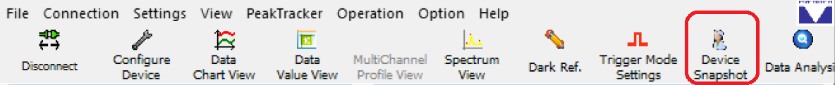

Hardware
 | Type | Product Number | Serial Number
Sensor | Klicken oder tippen Sie hier, um Text einzugeben. | Klicken oder tippen Sie hier, um Text einzugeben. | Klicken oder tippen Sie hier, um Text einzugeben.
Probe | Klicken oder tippen Sie hier, um Text einzugeben. | Klicken oder tippen Sie hier, um Text einzugeben. | Klicken oder tippen Sie hier, um Text einzugeben.
Additional Equipment | Klicken oder tippen Sie hier, um Text einzugeben. | Klicken oder tippen Sie hier, um Text einzugeben. | Klicken oder tippen Sie hier, um Text einzugeben.

Measurement
☐ Distance | ☐ Topography | ☐ Thickness | ☐ Other
Sample Description (Wafer, Glass Vial, PCB, Metal Plate, etc.)
Klicken oder tippen Sie hier, um Text einzugeben.

Problem
When does the problem occur?
☐ Permanent | ☐ Sporadic | ☐ After switching on | ☐ After long runtime
☐ Other (please give details)
Klicken oder tippen Sie hier, um Text einzugeben.

Symptoms / Problem Description / Pictures
Klicken oder tippen Sie hier, um Text einzugeben.

